Assignment 4
BS6202

Download and install “RforProteomics” library on your R console and answer the following questions:

Task 1: Using the attached “task1.mzXML” file, answer the below questions. [2 marks]

- How many individual spectra’s does this file contain?

suppressWarnings(library("mzR")) ## the software package
task1 <- openMSfile("task1.mzXML")
task1
Mass Spectrometry file handle.
Filename: task1.mzXML
Number of scans: 5

2. Plot Intensity vs m/z for all the spectra this file contains.

rawdata <- readMSData("task1.mzXML", msLevel = 2, verbose = FALSE)
plot(rawdata, full=TRUE)
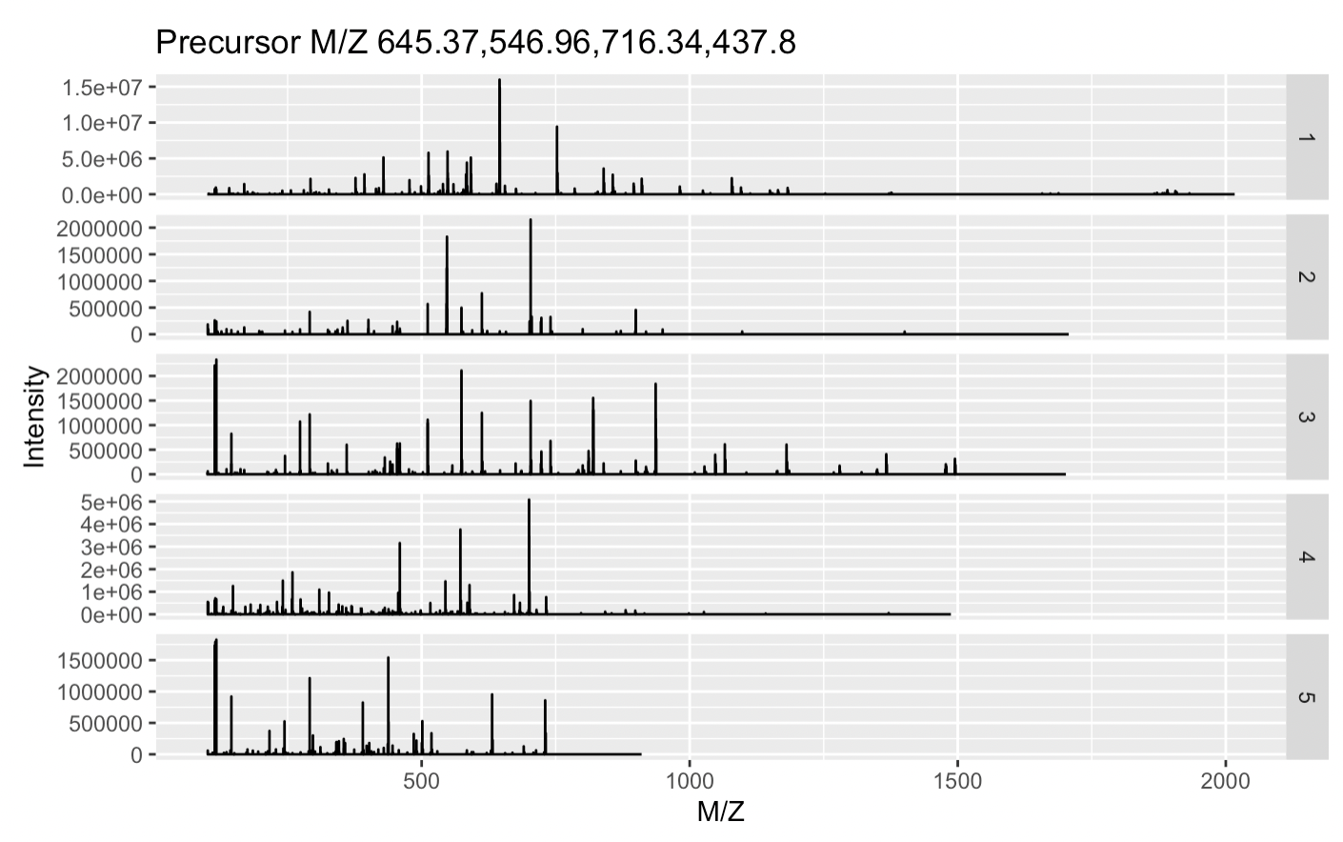

Task 2: Using the “cleaver” package in R for in-silico cleavage of polypeptides, simulate the following cleavages. [2 marks]

- Cleave the polypeptide “LAAGKVEDSD” using the enzyme “Trypsin”, assuming 100% efficiency of the enzyme.

library("cleaver")
cleave("LAAGKVEDSD", enzym = "trypsin")
$LAAGKVEDSD =
'LAAGK''VEDSD'

- Cleave the polypeptide “SITKIKAREILD” using enzyme “Trypsin”, assuming 0 or 1 missing cleavage position.

cleave("SITKIKAREILD", enzym = "trypsin", missedCleavages = 0:1)
#cleave("SITKIKAREILD", enzym = "trypsin", missedCleavages = 0)
#cleave("SITKIKAREILD", enzym = "trypsin", missedCleavages = 1)
$SITKIKAREILD =
'SITK''IK''AR''EILD''SITKIK''IKAR''AREILD'

Task 3: Download the following file from ftp://ftp.pride.ebi.ac.uk/pride/data/archive/2019/10/PXD014124/20190202_QExHFX2_RSLC8_PST_HeLa_10ng_1ulLoop_muPAC_1hr_15k_7.raw

This data file contains the LC-MS data of a human NCI-7 Cell Line and will be used for below analysis

1. Convert this “.raw” file into “mzML” format using the “msconvert” or any other tool of your choice.
See https://github.com/ydchen17/PG-BS6202/blob/main/BS6202%20Assignment%204/20190202_QExHFX2_RSLC8_PST_HeLa_10ng_1ulLoop_muPAC_1hr_15k_7.mzML

2. Install and setup “Fragpipe” (https://fragpipe.nesvilab.org/)
3. Using “Fragpipe” run “MsFragger” on this converted dataset with the appropriate proteome database and write an 1 page summary on your interpretation of the output.

The detailed project and protocols are available at https://www.ebi.ac.uk/pride/archive/projects/PXD014124
The output files are available at https://github.com/ydchen17/PG-BS6202/tree/main/BS6202%20Assignment%204/output

Peak picking is applied to the data for centroiding (Adusumilli & Mallick, 2017). Other options are by default.

Summary of the results:

The dataset is part of Stadlmann et al. (2019)’s study comparing Micropillar Array-Based Chromatography based low-input proteomics to conventional nanoflow HPLC columns based approach, which describes a proteomic result of the new system, i.e. muPAC, which is said to identify twice as many proteins and peptides.

Here we deploy Open search workflow for PTM analysis in the MS datasets using FragPipe by comparing the data to human protein database. Below shows the workflow:
Figure source: https://www.bgi.com/us/mass-spec-services/proteome-and-ptm-profiling/

The details of the bioinformatics workflow is given at https://fragpipe.nesvilab.org/docs/tutorial_fragpipe_workflows.html
Interpretations of the results are given similar to what are stated on https://fragpipe.nesvilab.org/docs/tutorial_fragpipe_outputs.html

According to filter.log, this allows us to first discover 5274 peptide-spectrum matches (PSMs) with 1% false discovery rate (FDR), as is in psm.tsv. Based on this, we further map 4170 peptide sequences, as is in peptide.tsv, and 4501 ions, as is in ion.tsv, which enables inference of 1347 proteins. Since we only have a group, so there is no combined_protein files as stated in the original protocol. It is quite clear that our current proteomic pipeline is sensitive to all kinds of different, according to the protein profile, as is shown in the figure below.

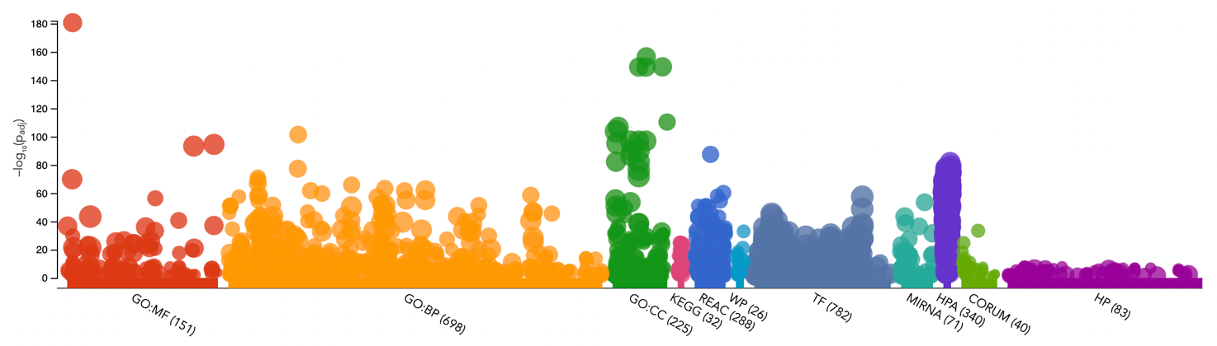
Figure source: https://biit.cs.ut.ee/gplink/l/jNw0M28rRf

A sequential FDR estimation further explore the result with lower FDR, which narrows down the result to 5221 PSMs under 0.26% FDR, 4132 peptides under 0.33% FDR, 4459 ions under 0.31% FDR. These results are added to protein.tsv and peptide as modifications. The post-translational modifications (PTM) profile details are given in global.profile.tsv and global.modsummary.tsv. The procedure of the analysis is illustrated as below:

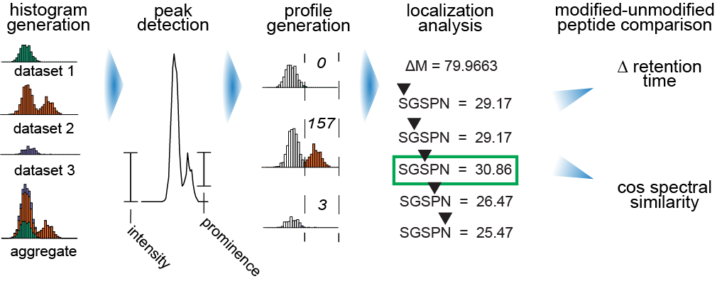
Figure source: https://github.com/Nesvilab/PTM-Shepherd

[6 marks]

References
Adusumilli, R., & Mallick, P. (2017). Data Conversion with ProteoWizard msConvert BT - Proteomics: Methods and Protocols (L. Comai, J. E. Katz, & P. Mallick (eds.); pp. 339–368). Springer New York. https://doi.org/10.1007/978-1-4939-6747-6_23
Stadlmann, J., Hudecz, O., Krššáková, G., Ctortecka, C., Van Raemdonck, G., Op De Beeck, J., Desmet, G., Penninger, J. M., Jacobs, P., & Mechtler, K. (2019). Improved Sensitivity in Low-Input Proteomics Using Micropillar Array-Based Chromatography. Analytical Chemistry, 91(22), 14203–14207. https://doi.org/10.1021/acs.analchem.9b02899

